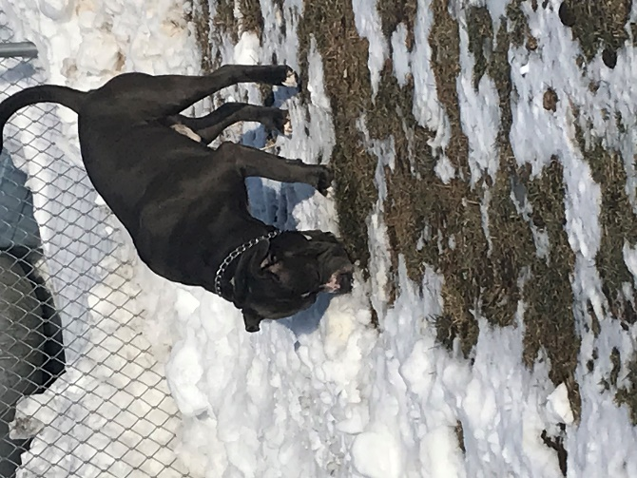Bai

|  |  |  |  |  |  |  |  |
| --- | --- | --- | --- | --- | --- | --- | --- |
| **Date:** | 2/08/22 | | | **Time:** | | 6pm | |
|  | | | | | | | |
| **Food:** | | Ate all food | Ate some food | | Ate no food | | |
| **Potty:** | | Normal | Not very regular | | Problems | | |
| **Behaviour:** | | Very well behaved | Well behaved | | A little bit naughty! | | |
| **Comfort:** | | Happy | Slightly nervous | | Very fretful and anxious | | |
|  | | | | | | | | |
|  | | | | | | | | |
| **Activities Done:** | | Kilo is such a happy dog! He is so smart and always has a huge smile on his face! He really likes when we add more toys in his kennel and give him extra blankets to be extra comfy! | | | | |
|  | | | | | | | | |
| **Comments/ Problems:** | | Didn’t observe anything abnormal today! We like to spoil Kilo and give a little canned food at night as a reward for being such a good boy!!! | | | | |

Kilo

REPORT CARD